**COMPUTER NETWORKS LAB**

**NAME: TULASI L**

**SRN : PES1UG20CS607**

**SECTION : J**

**WEEK NO: 4**

**Observation 1:**

**Wireshark capture**

**Pinging [www.flipkart.com](http://www.flipkart.com)**

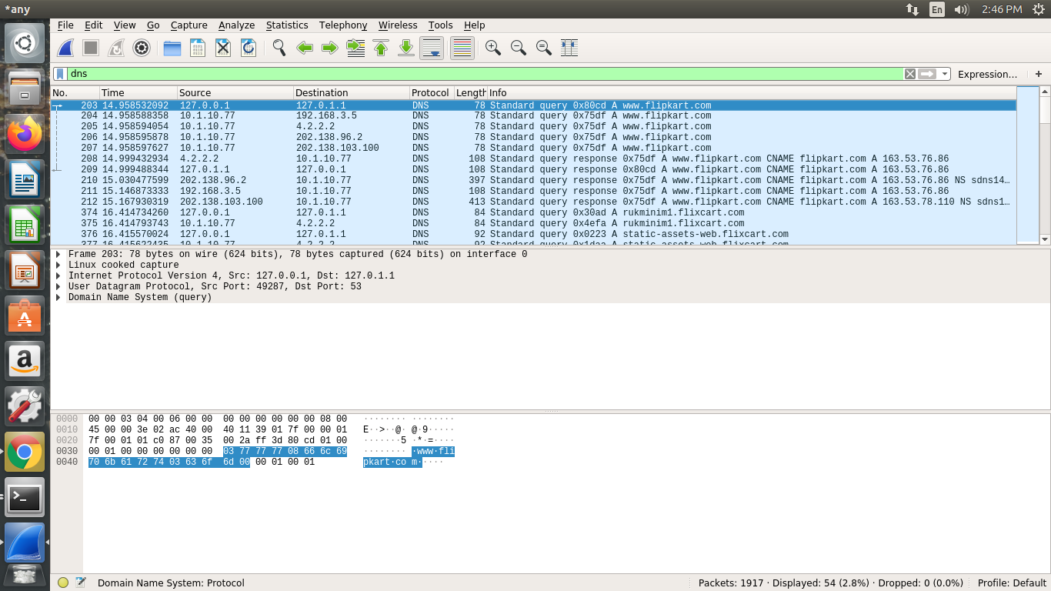

Part 1: Setting Up a Local DNS Server

Task 1: Configure the User/Client Machine

The IP Address of the client machine is 10.0.10.77 and the IP Address of the server machine is 10.0.10.95

Command: sudo nano /etc/resolvconf/resolv.conf.d/head

sudo resolvconf –u

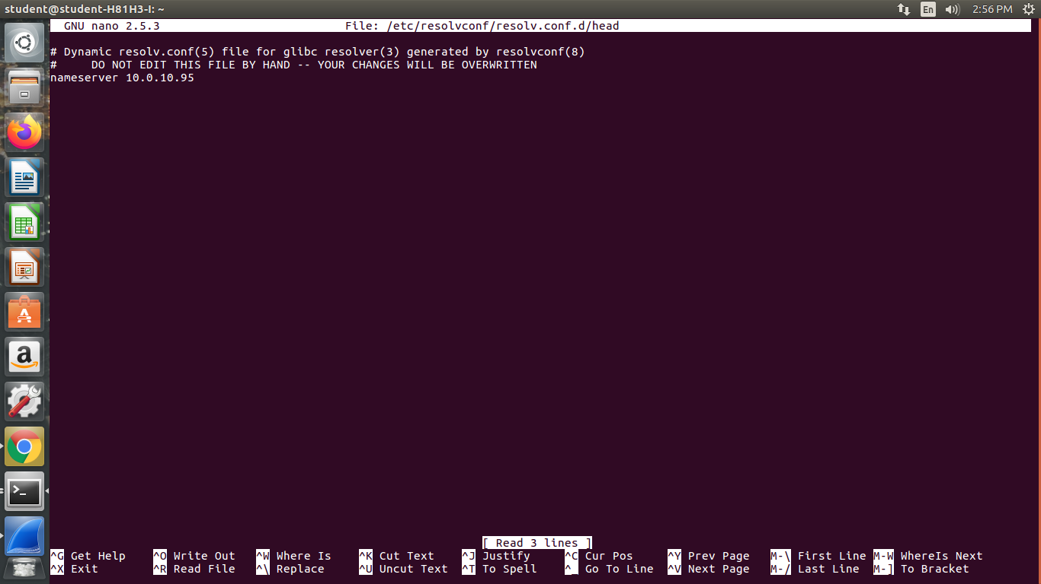

Observation 2:

Pinging [www.flipkart.com](http://www.flipkart.com)

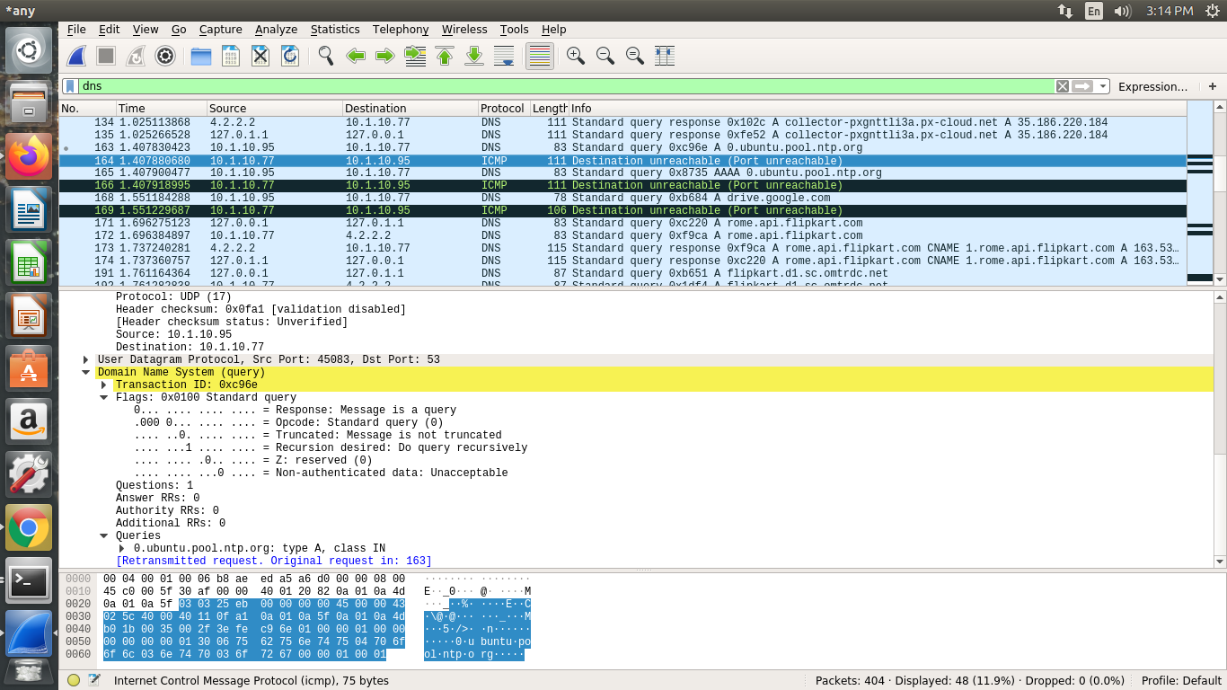

Task 2 – Setting Up Local DNS Server

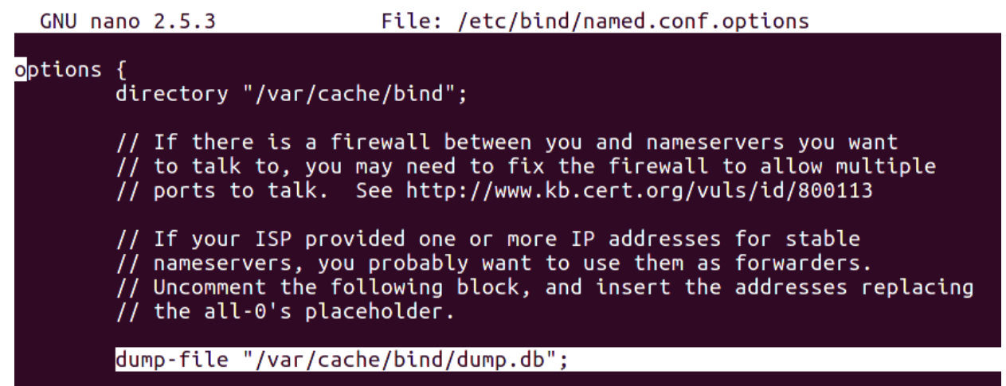

Observation 3:

Wireshark capture:

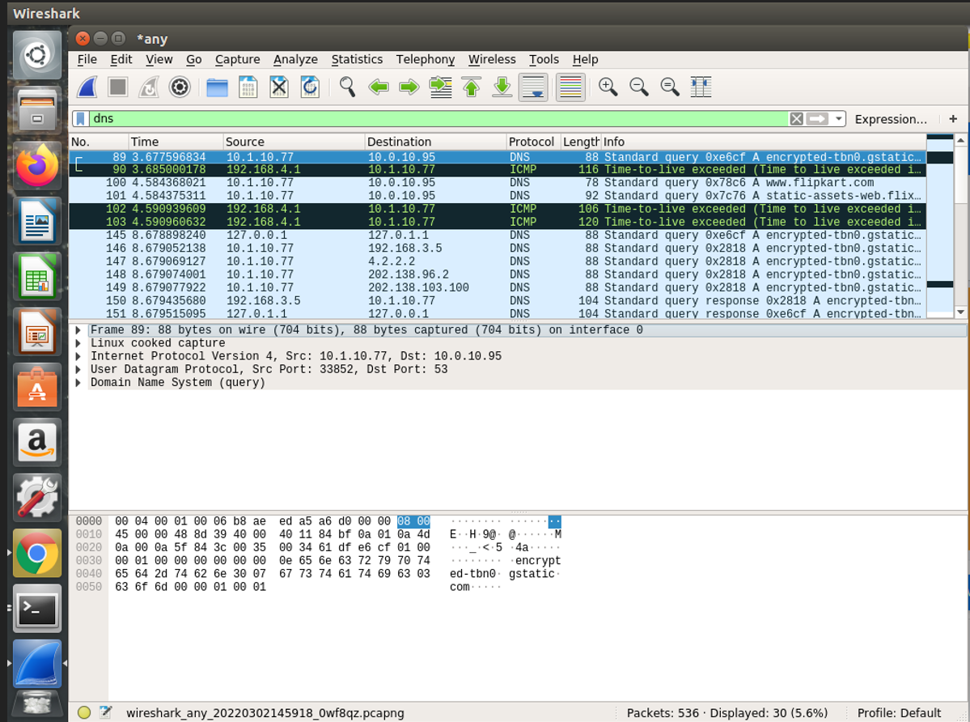

Observation 4:

[www.flipkart.com](http://www.flipkart.com) DNS cache